App/ web flow

Screen ID | Screen Name | Access Level | Primary Objective | UI/UX Core Components | Key Functional Actions
SCR-01 | Authentication & Command Onboarding | Public / Role-Based | Secure entry point and multi-tenant city selection. | Glassmorphism login panel, city drop-down menu, MFA input, role selector badge. | - Authenticate via Firebase/OAuth.  - Select target jurisdiction (e.g., Sehore, Ashta).  - Load role-based security context.
SCR-02 | Operator Main Console (H3 Spatial Grid) | Dispatch Operator | Real-time interactive urban telemetry monitoring via Uber H3 spatial grid. | Mapbox/Leaflet webGL map canvas, H3 hexagonal overlay, dynamic legend filter drawer, live ticker stream. | - Toggle context lenses (Mobility, Climate, Vulnerability).  - Zoom/pan across Resolution 8 H3 cells.  - Click H3 cell to trigger detail inspection panel.
SCR-03 | H3 Cell Detail & Action Drawer | Dispatch Operator | Drill-down into raw telemetry metrics and review AI-synthesized dispatch directives. | Radar chart (lens scores), telemetry feed list, Gemini 2.5 Flash narrative card, one-click action buttons. | - Inspect $S_{m},S_{c},S_{v}$ sub-scores.  - Review calculated Composite Risk Score ($R_{c}$).  - Click [Approve & Dispatch] or [Override].
SCR-04 | Field Unit Mobile App (PWA) | Field Specialist | Task execution interface optimized for low-bandwidth mobile environments. | Clean vertical task card, Mapbox turn-by-turn route preview, status toggle bar, camera upload trigger. | - Receive real-time push/SMS alerts.  - Update task status (In Transit $→$ Work Started $→$ Resolved).  - Submit geotagged photo proof of completion.
SCR-05 | Administrator Rules & Triage Engine | Municipal Admin | Fine-tune algebraic formulas, dynamic weighting factors, and emergency escalation policies. | Parameter slider controls ($W_{m},W_{c},W_{v}$), formula dry-run simulator, system log auditor. | - Adjust weights dynamically based on season (e.g., monsoon elevation).  - Modify risk score threshold $R_{c}$ (default $≥7.0$).
SCR-06 | Incident Audit & Analytics Portal | Admin / Executive | Historical review of dispatch velocity, fuel savings, and operational audit trails. | Data tables, CSV export toolbar, trend charts (response times vs. historic baselines). | - Filter logs by date range and city sector.  - Download immutable audit trails for compliance.

2. Complete Flow Paths & System Execution Logic
Flow Path 1: Automated Detection & Operator Action (Happy Path)

[Telemetry Sources: GTFS-RT / OpenWeather API / Citizen WhatsApp Stream]
│
▼
[Async Ingestion Layer: Python FastAPI on Google Cloud Run]
│
▼
[Spatial Engine: Uber H3 Indexing (Resolution 8 / ~0.7 km²)]
│
▼
[Parallel Lenses Engine: Mobility (Sm) | Climate (Sc) | Vulnerability (Sv)]
│
▼
[Triage Matrix Engine: Calculates Rc = (Wm*Sm) + (Wc*Sc) + (Wv*Sv)]
│
┌───────┴───────┐
Rc < 7.0 Rc >= 7.0
│ │
▼ ▼
[Log to Firestore] [Trigger Emergency Workflow]
│
▼
[Gemini 2.5 Flash Generates Action Directive]
│
▼
[Next.js Dashboard: H3 Cell Pulses RED]
│
▼
[Operator Reviews & Clicks "Approve"]
│
▼
[PWA / SMS Dispatch Sent to Field Unit]

Flow Path 2: Field Resolution & Automated Recovery Loop

[Field Specialist Receives Alert on PWA]
│
▼
[Click "Accept Task"] ──> Dashboard Updates Cell Status to "Field Unit En Route"
│
▼
[Field Unit Arrives & Clears Waterlogging / Deploys Equipment]
│
▼
[Click "Mark Completed" + Upload Geotagged Photo]
│
▼
[Ingestion Stream Recalculates Lens Scores (Sm drops as transit speeds resume)]
│
▼
[Triage Matrix: New Rc Score < 7.0]
│
▼
[Dashboard H3 Hexagon Automatically Transitions Red ──> Green]
│
▼
[Incident Log Archived to Cloud Firestore]

Technical Solution & Architecture Implementation Strategy
Core Technology Stack
┌───────────────────────────────────────────────────────────────────────────┐
│ METABOLICCITY AI TECH STACK │
├───────────────────────────────────────────────────────────────────────────┤
│ Frontend Web App │ Next.js 14 (App Router), React, Tailwind CSS, Mapbox GL │
│ Field Mobile App │ Progressive Web App (PWA), Service Workers, Twilio SMS│
│ Ingestion Gateway │ Python 3.11, FastAPI (Asynchronous execution) │
│ Compute Engine │ Google Cloud Run (Serverless microservices) │
│ Spatial Indexing │ Uber H3 Spatial Library (PyH3 / H3-js) │
│ State Storage │ Google Cloud Firestore (Real-time NoSQL database) │
│ Generative Engine │ Vertex AI / Gemini 2.5 Flash API │

Key Implementation Modules
- Deterministic Triage Engine: Prevents AI hallucination risks by relying entirely on transparent, verifiable mathematics for critical decision-making:
$$\text{Composite Risk Score }\left(R_{c}\right)=\left(W_{m}×S_{m}\right)+\left(W_{c}×S_{c}\right)+\left(W_{v}×S_{v}\right)$$
- Structured AI Narrator: Gemini 2.5 Flash is strictly constrained to output JSON objects following predefined dispatch templates. It parses high-dimensional spatial metrics into clear, actionable natural language for dispatchers.
- Zero-Hardware Operating Model: Bypasses CapEx constraints by utilizing existing, public software feeds ("digital exhaust") rather than physical street hardware.
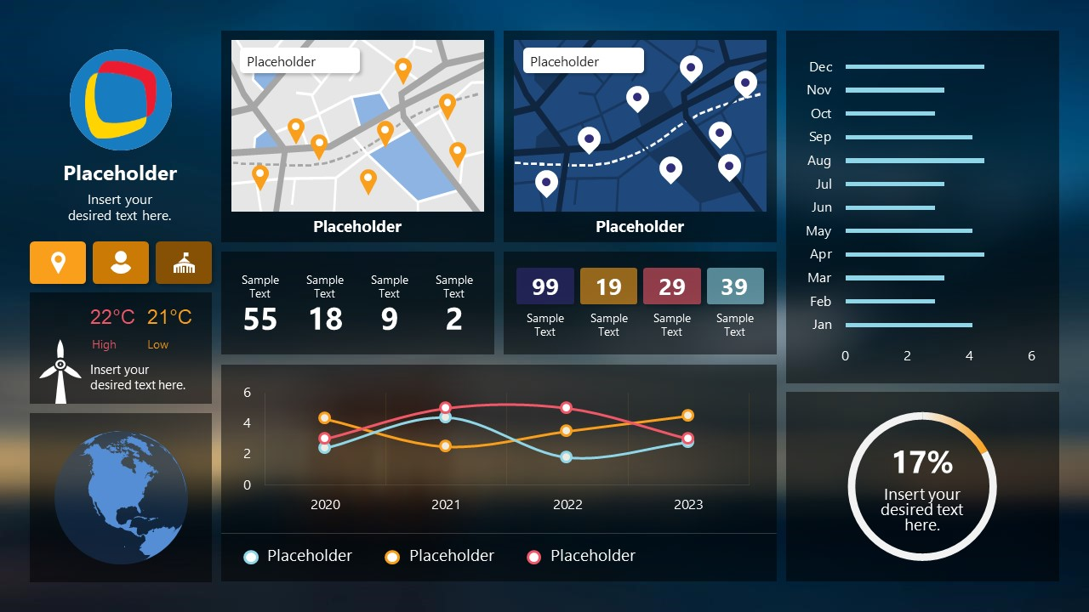


Complete Application Flowchart (User Journey)
┌──────────────────┐
│ Operator Log In │
└────────┬─────────┘
│
▼
┌───────────────────────────────────┐
│ Next.js Map Console Dashboard │
│ (Shows Live H3 Hexagonal Grid) │
└────────┬──────────────────────────┘
│
├───► Hexagon displays GREEN (Rc < 7.0) ──► Normal monitoring state
│
└───► Hexagon pulses RED (Rc >= 7.0)
│
▼
┌─────────────────────────────────────────────────┐
│ Operator Clicks Red Hexagon │
│ - Opens Cell Detail Drawer │
│ - Views Raw Lens Scores (Sm, Sc, Sv) │
│ - Reads Gemini 2.5 Flash Action Directive │
└────────────────────────┬────────────────────────┘
│
┌─────────────┴─────────────┐
│ │
▼ ▼
[ Operator Approves Alert ] [ Operator Overrides Alert ]
│ │
│ ▼
│ Reason Logged in System;
│ Hexagon returned to Green
▼
┌─────────────────────────────────────────────────┐
│ System Triggers Field Alert │
│ - SMS sent to Field Unit │
│ - Task appears on Field PWA App │
└────────────────────────┬────────────────────────┘
│
▼
┌─────────────────────────────────────────────────┐
│ Field Specialist Action │
│ - Accepts task on PWA Mobile App │
│ - Resolves blockage / diverts traffic │
│ - Submits completion status + photo │
└────────────────────────┬────────────────────────┘
│
▼
┌─────────────────────────────────────────────────┐
│ System Recovers │
│ - Telemetry feeds update │
│ - Risk Score Rc drops below 7.0 │
│ - Dashboard Hexagon automatically turns GREEN │
└─────────────────────────────────────────────────┘

